Motor Driver BTS7960 43A

<http://www.instructables.com/id/Motor-Driver-BTS7960-43A/>

C:\Projects\KiCad\LM629Driver\Motor Driver BTS7960 43A.docx

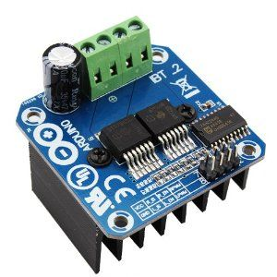The motor driver channel Will be disable if EN Pin is LOW

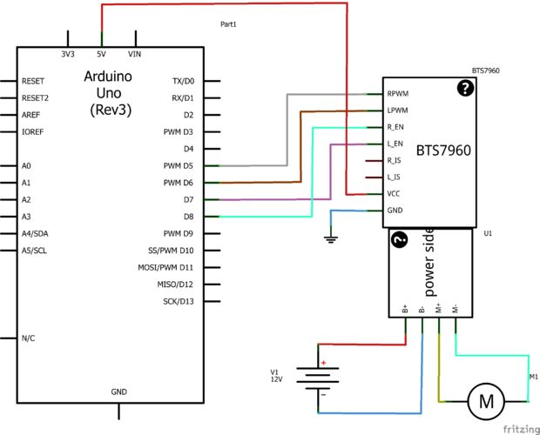

## [Dr Rainer Hessmer](http://www.hessmer.org/blog)

<http://www.hessmer.org/blog/2013/12/28/ibt-2-h-bridge-with-arduino/>

The IBT-2 H-bridge module from wingxin is an inexpensive, high power motor driver based on two BTS7960 chips and is readily available from various ebay vendors; see e.g. [here](http://www.ebay.com/itm/Semiconductor-BTS7960B-Stepper-Motor-Driver-43A-H-Bridge-Drive-PWM-For-Arduino-/251409543900?pt=LH_DefaultDomain_0&hash=item3a892d32dc).

[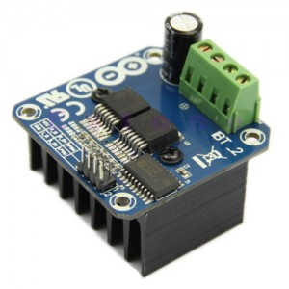](http://www.hessmer.org/blog/wp-content/uploads/2015/06/IBT-2Module.jpg)

The [link](http://www.ebay.com/itm/Semiconductor-BTS7960B-Stepper-Motor-Driver-43A-H-Bridge-Drive-PWM-For-Arduino-/251409543900?pt=LH_DefaultDomain_0&hash=item3a892d32dc) provides more details but here are a few key parameters.

* Input voltage : 6V-27V
* Maximum Current : 43A
* Input level : 3.3V-5V

I am not sure whether the heat sink is sufficient for handling 43A but even if one does not drive the unit to its limits the specifications are still impressive given the typical price point of this module (currently between $13 and $17 including free shipping from China). There is relatively little information available about how to hook up the module with an Arduino controller. This [thread on the Arduino forum](http://forum.arduino.cc/index.php?topic=148482.0) was useful but the solution wastes a few pins and does not demonstrate bidirectional motor control. In this post I describe a slightly more complete solution that uses an Arduino controller with connected potentiometer to drive a motor via the IBT-2 module from full reverse speed to full forward speed.

For reference here is the description of the input ports and the two supported usage modes (image taken from [one of the ebay postings](http://www.ebay.com/itm/Semiconductor-BTS7960B-Stepper-Motor-Driver-43A-H-Bridge-Drive-PWM-For-Arduino-/251409543900?pt=LH_DefaultDomain_0&hash=item3a892d32dc)).

In this post **I leverage usage mode one below.**

[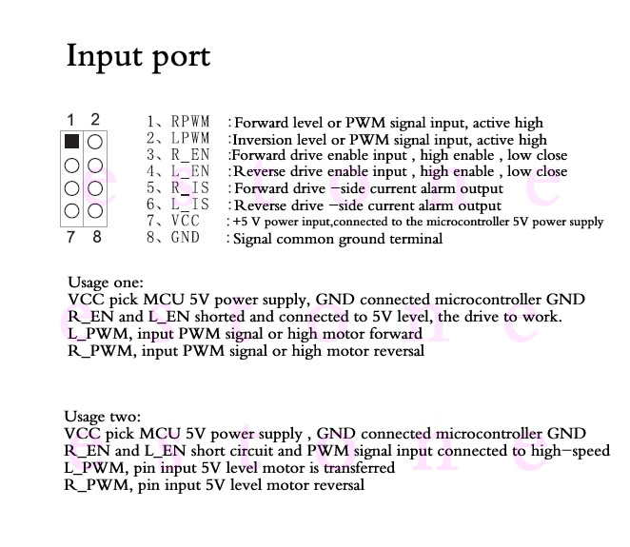](http://www.hessmer.org/blog/wp-content/uploads/2015/06/IBT-2-Input-Ports.jpg)

Here is the associated Arduino sketch:

|  |  |
| --- | --- |
| 1  2  3  4  5  6  7  8  9  10  11  12  13  14  15  16  17  18  19  20  21  22  23  24  25  26  27  28  29  30  31  32  33  34  35  36  37  38  39  40  41  42  43  44  45  46 | /*  IBT-2 Motor Control Board driven by Arduino.    Speed and direction controlled by a potentiometer attached to analog input 0.  One side pin of the potentiometer (either one) to ground; the other side pin to +5V    Connection to the IBT-2 board:  IBT-2 pin 1 (RPWM) to Arduino pin 5(PWM)  IBT-2 pin 2 (LPWM) to Arduino pin 6(PWM)  IBT-2 pins 3 (R_EN), 4 (L_EN), 7 (VCC) to Arduino 5V pin  IBT-2 pin 8 (GND) to Arduino GND  IBT-2 pins 5 (R_IS) and 6 (L_IS) not connected  */    int SENSOR_PIN = 0; // center pin of the potentiometer    int RPWM_Output = 5; // Arduino PWM output pin 5; connect to IBT-2 pin 1 (RPWM)  int LPWM_Output = 6; // Arduino PWM output pin 6; connect to IBT-2 pin 2 (LPWM)    void setup()  {    pinMode(RPWM_Output, OUTPUT);    pinMode(LPWM_Output, OUTPUT);  }    void loop()  {    int sensorValue = analogRead(SENSOR_PIN);      // sensor value is in the range 0 to 1023    // the lower half of it we use for reverse rotation; the upper half for forward rotation    if (sensorValue < 512)    {      // reverse rotation      int reversePWM = -(sensorValue - 511) / 2;      analogWrite(LPWM_Output, 0);      analogWrite(RPWM_Output, reversePWM);    }    else    {      // forward rotation      int forwardPWM = (sensorValue - 512) / 2;      analogWrite(LPWM_Output, forwardPWM);      analogWrite(RPWM_Output, 0);    }  } |

The following Fritzing diagram illustrates the wiring. B+ and B- at the top of the diagram represent the power supply for the motor. A 5k or 10k potentiometer is used to control the speed.

[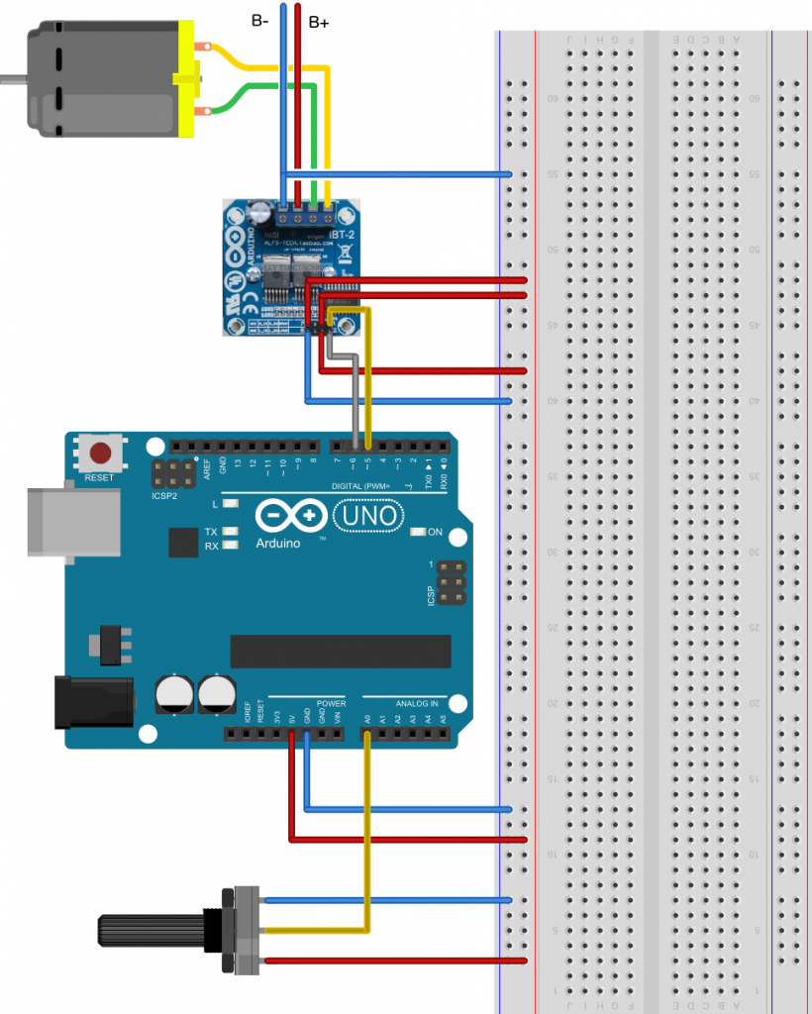](http://www.hessmer.org/blog/wp-content/uploads/2013/12/IBT-2-with-Arduino_bb1.png)